|  |  |  |
| --- | --- | --- |
|  | **GUJARAT TECHNOLOGICAL UNIVERSITY**  Chandkheda, Ahmedabad  Affiliated |  |

Sardar Vallabhbhai Patel Institute of Technology

Vasad-041

A Report On-

**Internet of Things**

Under the course of

**DESIGN ENGINEERING – 1B (2130005)**

B. E. II, Semester – IV

**(Information and Technology Branch)**

***Submitted by:***

Team ID: 34478

|  |  |  |  |
| --- | --- | --- | --- |
| **Sr.** | **Name of student** | | **Enrolment No.** |
|  |  | |  |
| 1 | Kaustubh Wade | | 160410116050 |
| 2 | Naisargi Kothari | | 160410116051 |
| 3 | Parjita Munshi | | 160410116064 |
|  |  |
|  |  |

|  |  |
| --- | --- |
| **Prof. Amit Kariyani**  **(Faculty Guide)** | **Prof. N.V. Shah**  **(Head of Department)** |

**Academic year**

**(2017-2018)**

|  |  |  |
| --- | --- | --- |
|  | **GUJARAT TECHNOLOGICAL UNIVERSITY**  Chandkheda, Ahmedabad  Affiliated |  |

**CERTIFICATE**

This is to certify that the students namely, **Kaustubh Wade (160410116050), Naisargi Kothari (160410116051), Parjita Munshi (160410116064)** of ***B. E. (Information Technology) Semester IV*** have successfully completed the course work and related tasks for the course of **Design Engineering 1B (2130005)** during the academic term ending in the month of April 2018.

Date: 23-4-2018

Place: SVIT VASAD

**Prof. Mr. Amit Kariyani Prof. Mrs. N. V. Shah**

Head of the Department

**(Faculty in Charge) (Internal Examiner) (External Examiner)**

Table of Contents

1. Introduction 1

2. Canvases 2

2.1. A.E.I.O.U. Canvas 2

2.1.1. A-Activity 2

2.1.2. E-Environment 3

2.1.3. I-Interaction 3

2.1.4. O-Objects 3

2.1.5. U-Users 3

2.2. Mind Mapping Canvas 5

2.3. Empathy Mapping Canvas 6

2.3.1. Users 6

2.3.2. Stakeholders 6

2.3.3. Activity 6

2.4. Ideation Canvas 8

2.4.1. People 8

2.4.2. Activities 8

2.4.3. Situation/Context/Location 8

2.4.4. Props/Possible Solution 9

2.5. Product Development Canvas 10

2.5.1. Purpose 10

2.5.2. People 10

2.5.3. Product Function 10

2.5.4. Product features 10

2.5.5. Components 10

3. Summary of findings of Prior Art Search on our project theme. 12

4. Summary of learning from reverse Engineering Activity 25

5. Learnings Need Matrix 26

6. Rough Prototype Model 28

7. Conclusion 29

# Introduction

Imagine a world in which every device in the home, workplace and car are connected. A world where the lights automatically turn on when the car approaches the driveway, the [coffee starts brewing](http://www.technologyguide.com/feature/coffee-tech/) when the morning alarm goes off and the front door automatically unlocks when approached by a member of the household, but stays locked when a stranger arrives on the front step. That is the type of world the Internet of Things can create.

# Canvases

## A.E.I.O.U. Canvas

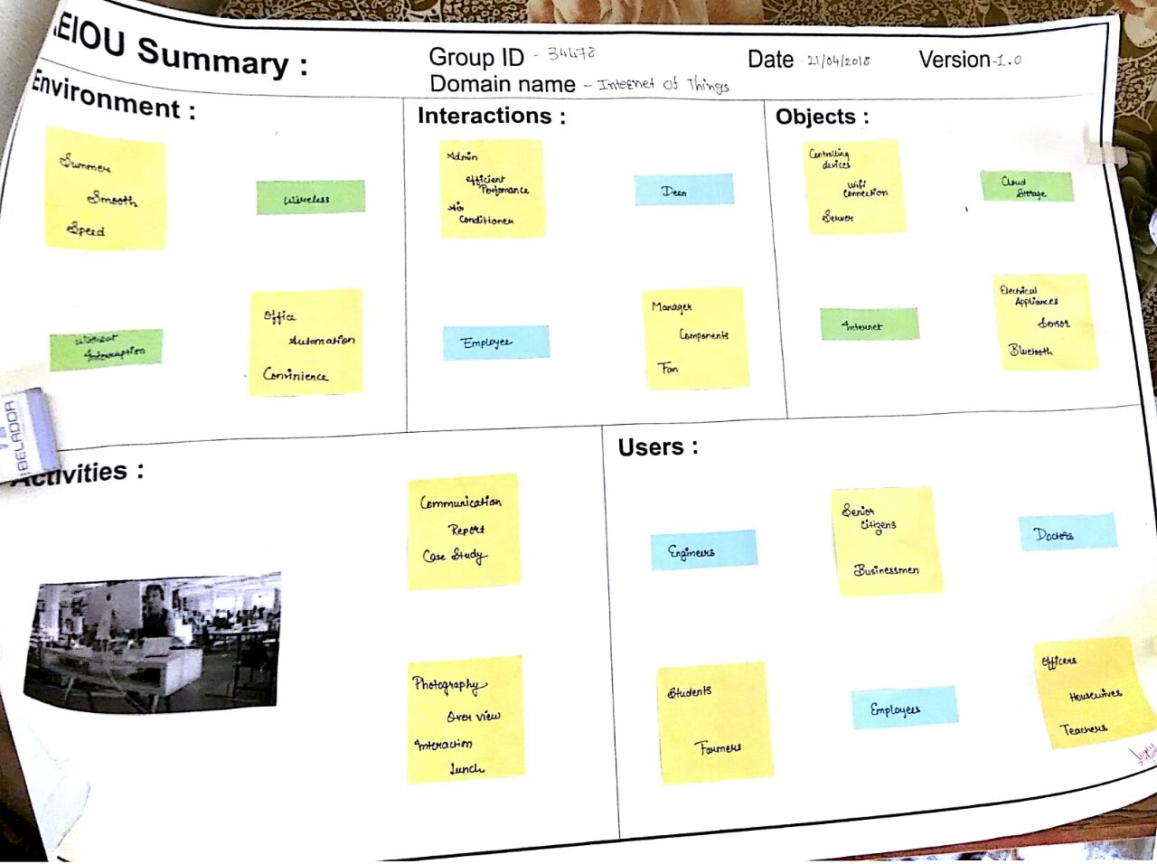

Figure 1 AEIOU Canvas

There are five topics that comes under AEIOU canvas.

### A-Activity

* Communication
* Report
* Overview
* Report
* Enjoyment
* Case study
* Photography
* Lunch

### E-Environment

* Smart Home
* Wearables
* Connected Cars
* Industries
* Smart City
* Agriculture
* Entertainment System

### I-Interaction

* Admin
* Manager
* Employee
* Components
* Fan
* Air-conditioner

### O-Objects

* Controlling Device
* Electrical Appliances
* Internet
* Wi-Fi Connection
* Sensors
* Cloud Storage
* Server
* Bluetooth

### U-Users

* Engineers
* Senior Citizens
* Officers
* Doctors
* Businessmen
* Employers
* Students
* Teachers

## Mind Mapping Canvas

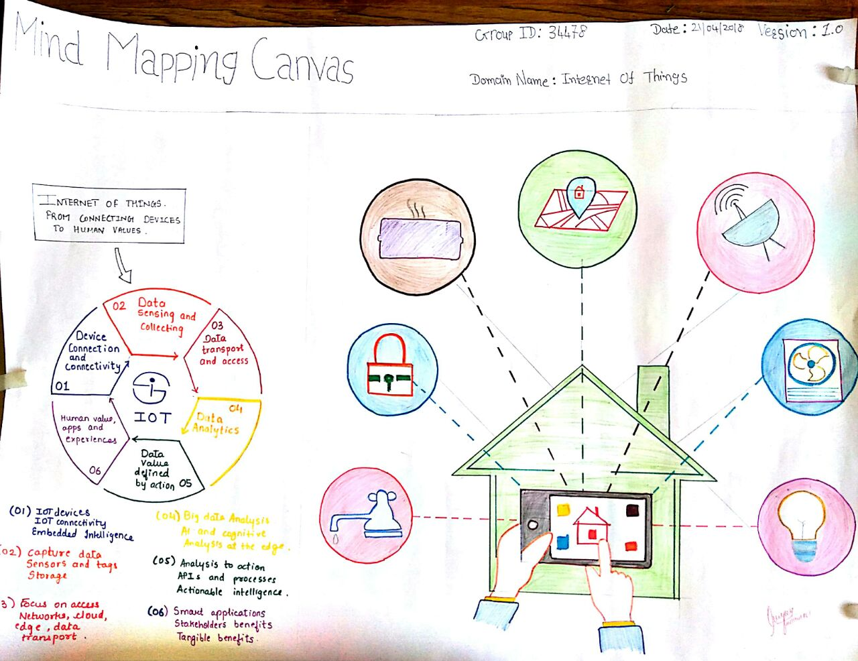

Figure 2 Mind Mapping Canvas

There are 5 features in the Mind Mapping Canvas.

* Users
* Activity
* Function
* Features
* Components

## Empathy Mapping Canvas

Here we are going to explain Users, Stack Holders and Activity. And hear story boarding which have one happy story and one sad story.

### Users

* Students
* House Wives
* Doctors
* Senior Citizens
* Teachers

### Stakeholders

* Manufacturers
* Engineers
* Servants
* Businessmen
* Dealers

### Activity

* Easy Availability for Applications
* Home Security
* Multi-Tasking
* Data Capture
* Automation
* Controlling Appliances
* Saving Electricity

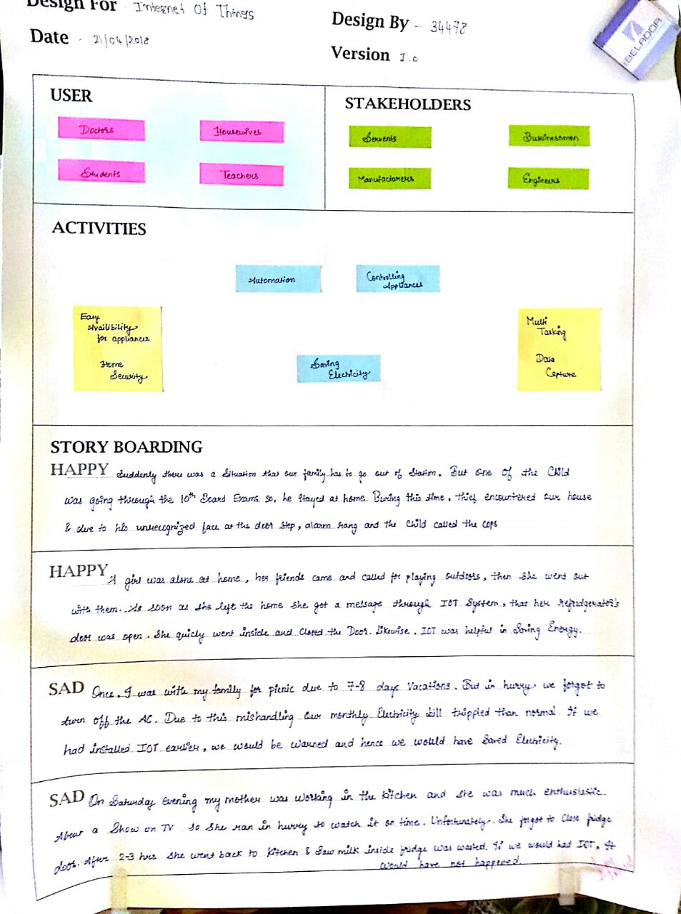

Figure 3 Empathy Mapping Canvas

## Ideation Canvas

We have described activities of people, situation and location and the problems which they face. This canvas is very helpful to reach near goal as it helped us to know the areas on which we need to focus.

### People

* Senior Citizens
* House Wives
* Businessmen
* Engineers
* Students
* Teachers
* Doctors

### Activities

* Local Sensing
* Data Capture
* Home Security
* Automation
* Home Security
* Controlling Devices
* Saving Electricity
* Multi-Tasking

### Situation/Context/Location

* Home Invasion
* Safety
* Car Parking
* Smart Metering
* Smart Farming
* Gardening
* Industry
* Living room
* College

### Props/Possible Solution

* Controlling Devices
* Sensor
* Internet Connection
* Wi-Fi
* Electrical Appliances
* Cloud Storage
* Server
* Connectors
* Bluetooth

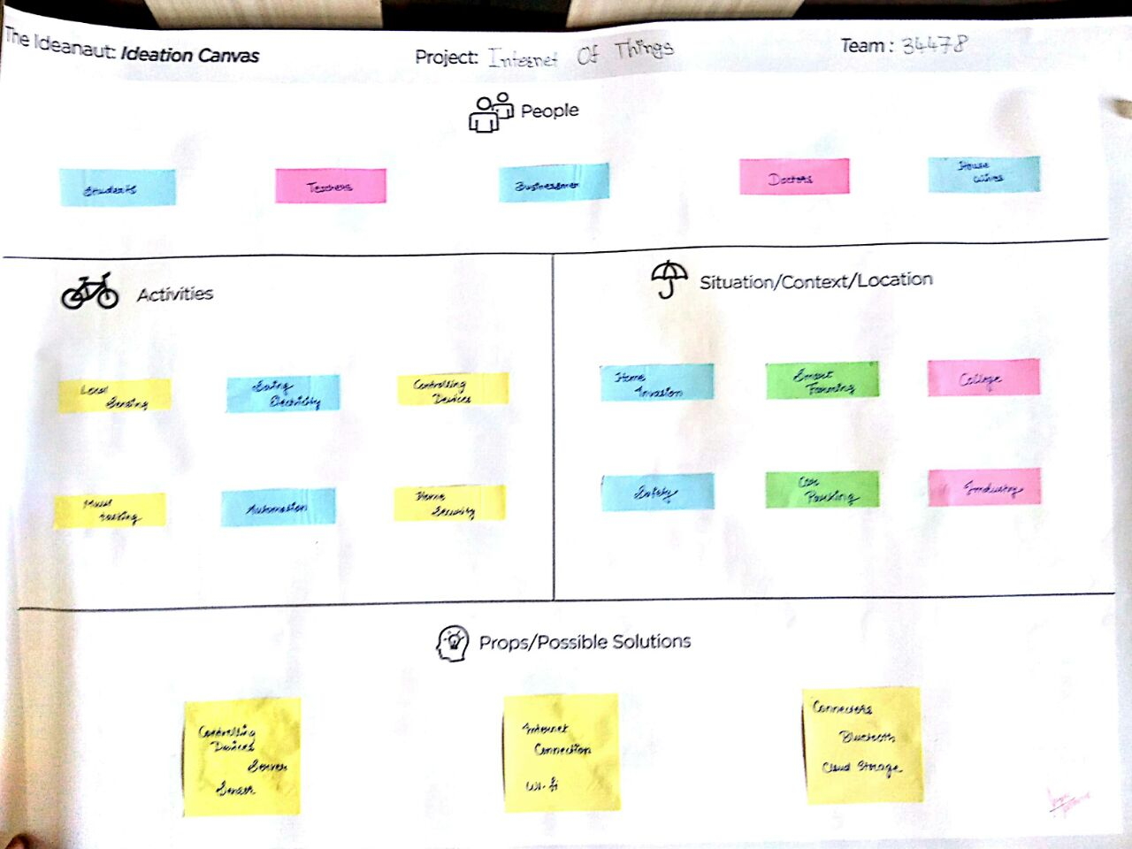

Figure 4 Ideation Canvas

## Product Development Canvas

This Canvas is helpful to understand the purpose, product experience and function of our project.

### Purpose

* Easy Handling
* Automation
* Smart Metering
* Energy Saving

### People

* House Wives
* Senior Citizens
* Students
* Engineers
* Doctors

### Product Function

* Manages range of devices
* Environmental monitoring
* Stores personal data
* Home automation

### Product features

* Saves Resources
* Security
* Command & Control
* Increases Task Efficiency
* Drives down Costs

### Components

* Controlling Devices
* Sensors
* Server
* Internet
* Wi-Fi Connection
* Connectors
* GPS, Bluetooth
* Cloud Storage
* Electrical Appliances

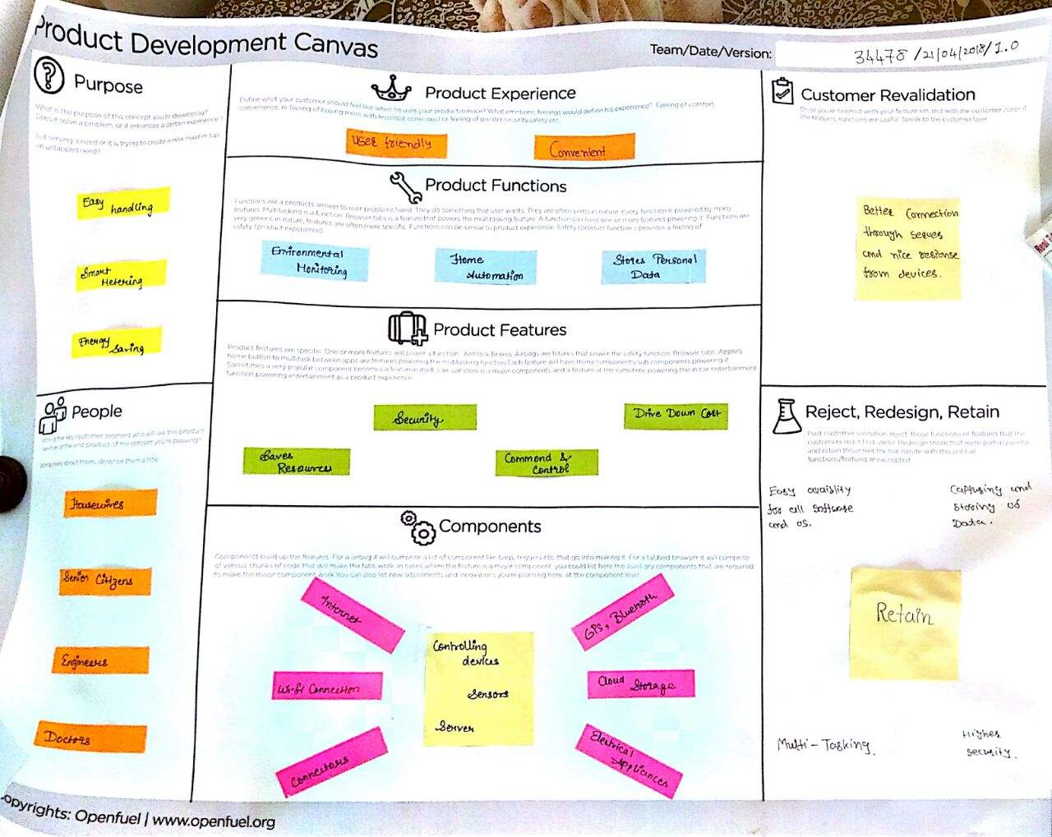

Figure 5 Product Development Canvas

# Summary of findings of Prior Art Search on our project theme.

The Internet of Things & Applications

If objects have a life that is innate, what would happen if these objects go further and were capable of storing data, sensing the environment and communicating with each other? That is the kind of life that the Internet of Thing offers to new electronic devices.

The Internet of Things (IoT) is the “network of interconnected sensor-equipped electronic devices that collect data, communicate with each other, and can be monitored or controlled remotely over the Internet” (Ahrens, “Making Sense of the Internet of Things”). The main goal of the IoT’s development is to connect the physical world and the environment to the Internet or to wireless networks, this would allow making objects, machines and work environments interactive. By using sensors, objects will be capable of exchanging data with other machines without the need of human intervention (Heires, “Preparing for the Internet of Things”). The IoT includes different technology infrastructure, devices and services such as the cloud, computing, data analytics and mobile communications. The IoT is not a prediction; it is a plausible trend that is moving forward, rapidly. It is estimated that by 2020, 50 billion devices around the world will be connected to the Internet. “A third of them will be computers, smartphones, tablets and TVs… The remaining two-thirds will be other kinds of things: sensors, actuators, and newly invented intelligent devices that monitor, control, analyze, and optimize our world (Burkitt, “A Strategist’s Guide to the Internet of Things”). There are major platforms and discoveries that have had a rich wage of complexity, global reach and novelty. But the IoT is for sure a trend that takes the development of interconnectivity to another level, one that once was only imaginable.

There will be a gigantic range of interconnected systems and products that the IoT will enable, from simple monitoring of home temperature and security to the quantified self … to fully networked factories and hospitals, to automated cities”. (Burkitt, “A Strategist’s Guide to the Internet of Things”). While it is true that the IoT will signify a major shift in the economy, politics and regulations from all government agencies, companies, and non-profit organizations, this paper will only focus on the effects that it will have on citizens by arguing that, although the development of the IoT is still on early phases regarding its development and spread, it is potentially a threat to both security and privacy.

Since the IoT is a rapidly growing trend, most major companies are seeking to get involved, there are enormous efforts to trigger this trend as something positive in the forthcoming future. A frequent discourse that is present in the media mentions the major positive technological improvement that the IoT represents. “Capitalist societies generally educate people to appreciate the conveniences and choices of modern consumer technologies” (Parks and Starosielski, 6). Who wouldn’t want a refrigerator that could tell you when you are running out of milk or that you need to replace one of its pieces? How fantastic it would be that your car could save information about what routes you take every day? Who would not want a house that can monitor and regulate the temperature to save energy? Or a watch that can save your sleep pattern information? These are all conveniences that are presented to potential consumers about the IoT, however little is said about what happens to all this information that is saved by the devices and whether this is safe or could be a treat for the consumers´ privacy.

If all devices are connected to the Internet, this means that they are vulnerable to be hacked. A recent study from HP titled “Internet of Things State of the Union” exposed relevant information that makes us more skeptical about relying on IoT as a safe technology. Some of the facts that the study revealed are that 70% of IoT devices were vulnerable to attack, 90% of the devices that were used for the study collect at least one piece of personal information via the device, the cloud, or its mobile application, 6 out of 10 devices that provide user interfaces were vulnerable to a range of issues and had weak credentials, 80% of devices along with their cloud and mobile application components failed to require passwords or a sufficient complexity and length and 70% of the devices along with their cloud and mobile application enable an attacker to identify valid user accounts through account enumeration (“Internet of Things Research Study Report”). Many devices connected to the Internet collect valuable personal information from users, such as name, address, date of birth, health information and credit cards numbers. What the HP study reveals is that all this information is vulnerable to potential hacker attacks.

The fact that the infrastructure that supports the Internet-connected devices is unreliable and can fail represents a disadvantage to the IoT as well. The infrastructure that supports the Internet works differently across diverse geographical areas. For example, in Mexico Telmex has the monopoly as the company that provides Internet to users and companies. It is expensive, unreliable and it fails frequently. Users can spend hours or days without Internet, and Telmex’s support team is inefficient and fickle. Furthermore, since the Internet service is expensive, many individuals do not have this service, therefore the IoT could increase the damage caused by the digital divide.

CONCLUSION

Finally, there is the environmental impact that the development and spread of the global IoT will bring. “In 2007 media technologies were responsible for between 2.5% and 3% of the world’s greenhouse gas emissions, a figure that has only increased with the expansion of Internet infrastructure, emergence of new data centers, and intensified production and use of consumer electronics” (Parks and Starosielski, 14). If we take into consideration this information and the fact that by 2020, 50 billion devices around the world will be connected to the Internet, it is crucial that we think about the environmental impact that the IoT will cause and question what can be done to prevent it.

The IoT will be here sooner rather than later, for now it is a trend that is running fast to become a reality. Under this fact it is essential that we demand public access to technological knowledge about the IoT. Technology moves faster than the development of proper legal measures and action to regulate it. We need to ask how can we be certain that the IoT is something that will not harm our privacy and safety. Who is building this technology and who owns it? What institutions could we approach in case of concern or discomfort? Where is the line between what is legal and what is illegal? How much information are we willing to provide/compromise to these interconnected devices? What happens if we choose not to participate in this technology? What is it necessary to arise greater public interest in what are the implications of the interconnectivity of all the devices that rule our environmental daily life and habitus? All these questions are genuine and each one of them deserves an answer.

The Internet of Things for House

Internet of Things (IoT) term represents a general concept for the ability of network devices to sense and collect data from around the world, and then share that data across the Internet where it can be processed and utilized for various interesting purposes. The IoT is comprised of smart machines interacting and communicating with other machines, objects, environments and infrastructures. Now a day’s every person is connected with each other using lots of communication way.

Where most popular communication way is internet so in another word we can say internet which connect peoples. The essential idea of the Internet of Things (IoT) has been around for nearly two decades, and has attracted many researchers and industries because of its great estimated impact in improving our daily lives and society. When things like household appliances are connected to a network, they can work together in cooperation to provide the ideal service as a whole, not as a collection of independently working devices.

This is useful for many of the real-world applications and services, and one would for example apply it to build a smart residence; windows can be closed automatically when the air conditioner is turned on, or can be opened for oxygen when the gas oven is turned on. The idea of IoT is especially valuable or persons with disabilities, as IoT technologies can support human activities at larger scale like building or society, as the devices can mutually cooperate to act as a total system. Communication capability and remote manual control lead to the next step … how do I automate things and, based on my settings and with sophisticated cloud-based processing, make things happen without my intervention? That’s the ultimate goal of some IoT applications. And, for those applications to connect with and leverage the Internet to achieve this goal, they must first become “smart” (incorporate an MCU/embedded processor with an associated unique ID) then connected and, finally, controlled. Those capabilities can then enable a new class of services that makes life easier for their users.

The term Internet of Things was first coined by Kevin Ashton in 1999 in the context of supply chain management. However, in the past decade, the definition has been more inclusive covering wide range of applications like healthcare, utilities, transport, etc. Although the definition of „Things‟ has changed as technology evolved, the main goal of making a computer sense information without the aid of human intervention remains the same. A radical evolution of the current Internet into a Network of interconnected objects that not only harvests information from the environment (sensing)and interacts with the physical world (actuation/command/control), but also uses existing Internet standards to provide services for information transfer, analytics, applications, and communications.

APPLICATIONS

This system is designed for a shopping complex mall but it can be also used in various organizations like educational Notice board system or at Railway station, Bus stand and Air-port to display the information and notification. In mall it is also used to control the humidity and temperature of mall via central AC by using temperature sensor. In Industrial organization it can be also used. E-display system may be used to display Emergency message in Hospitals. Some areas where IoT frequently used

Smart cities: -

To make the city as a smart city to engage with the data exhaust produced from your city and neighborhood.

• Monitoring of parking areas availability in the city.

• Monitoring of vibrations and material conditions in buildings, bridges and historical monuments.

• Detect Android devices, iPhone and in general any device which works with Bluetooth interfaces or Wi-Fi.

Domestic & Home Automation: -

In home by using the IoT system remotely monitor and manage our home appliances and cut down on your monthly bills and resource usage.

• Energy and Water Use: Energy and water supply consumption monitoring to obtain advice on how to save cost and resources.

• Remote Control Appliances: Switching on and off remotely appliances to avoid accidents and save energy.

• Intrusion Detection Systems: Detection of windows and doors openings and violations to prevent intruders.

• Art and Goods Preservation: Monitoring of conditions inside museums and art warehouses.

CONCLUSION

The IoT promises to deliver a step change in individuals‟ quality of life and enterprises‟ productivity. Through a widely distributed, locally intelligent network of smart devices, the IoT has the potential to enable extensions and enhancements to fundamental services in transportation, logistics, security, utilities, education, healthcare and other areas, while providing a new ecosystem for application development. A concerted effort is required to move the industry beyond the early stages of market development towards maturity, driven by common understanding of the distinct nature of the opportunity. This market has distinct characteristics in the areas of service distribution, business and charging models, capabilities required to deliver IoT services, and the differing demands these services will place on mobile networks.

The Internet of Things

The Internet of Things, also called The Internet of Objects, refers to a wireless network between objects usually the network will be wireless and self-configuring, such as household appliances. The term "Internet of Things" has come to describe a number of technologies and research disciplines that enable the Internet to reach out into the real world of physical objects. [IoT 2008] Extending the current Internet and providing connection, communication, and inter-networking between devices and physical objects, or Things, is a growing trend that is often referred to as the Internet of Things. The Internet of Things (IoT), sometimes referred to as the Internet of Objects, will change everything including ourselves. IoT represents the next evolution of the Internet, taking a huge leap in its ability to gather, analyze, and distribute data that we can turn into information, knowledge and ultimately, wisdom [3]. The Internet of Things (IoT) can be described as connecting everyday objects like smart-phones, Internet TVs, sensors and actuators to the Internet where the devices are intelligently linked together enabling new forms of communication between things and people, and between things themselves [1]. Now anyone, from anytime and anywhere can have connectivity for anything and it is expected that these connections will extend and create an entirely advanced dynamic network. IoT technology can also be applied to create a new concept and wide development space for smart homes to provide intelligence, comfort and to improve the quality of life. Modern advances in electronics and communications Technologies have led to the miniaturization and improvement of the performance of computers, sensors and networking. These changes have given rise to the development of several home automation technologies and systems. According to, home automation can be useful to those who need to Access home appliances while away from their home and can incredibly improve the lives of the disabled.

Home Automation is automation of the home, housework or household activity. Home automation may include centralized control of lighting, HVAC (heating, ventilation and air conditioning), appliances, security locks of gates and doors and other systems, to provide improved convenience, comfort, energy efficiency and security. Home automation for the elderly and disabled can provide increased quality of life for persons who might otherwise require caregivers or institutional care. The popularity of home automation has been increasing greatly in recent years due to much higher affordability and simplicity through smartphone and tablet connectivity. The concept of the "Internet of Things" has tied in closely with the popularization of home automation. A home automation system integrates electrical devices in a house with each other. Through the integration of information technologies with the home environment, systems and appliances are able to communicate in an integrated manner which results in convenience, energy efficiency, and safety benefits. However, problems with complexity, competition between vendors, multiple incompatible standards and the resulting expense have limited the penetration of home automation to homes of the wealthy, or ambitious hobbyists. Home automation or smart homes can be described as introduction of technology within the home environment to provide convenience, comfort, security and energy efficiency to its occupants [3]. With the introduction of the Internet of Things, the research and implementation of home automation are getting more popular. Various wireless technologies that can support some form of remote data transfer, sensing and control such as Bluetooth, Wi-Fi, RFID, and cellular networks have been utilized to embed various levels of intelligence in the home [3]. Many of the home automation systems that are commercially available can be separated into two categories: locally controlled systems and remotely controlled systems. Locally controlled systems use an in-home controller to achieve home automation. This allows users complete use of their automation system from within their home via a stationary or wireless interface. Remotely controlled systems use an Internet connection or integration with an existing home security system to allow the user complete control of their system from their mobile device, personal computer, or via telephone from their home security provider. [2] There are a number of issues involved when designing a home automation system. It should provide a user- friendly interface on the host side, so that the devices can be easily setup, monitored, and controlled. Furthermore, the overall system should be swift enough to realize the true power of wireless technology.

RESULTS

The system allows the user to control appliances and lights in their home from a smart phones and PC from anywhere in the world through an internet connection. It also allows the user to control their units within their home from a wireless remote. In these papers we proposed a Novel technique that will give us best result. Which include prediction by providing Notifications to the user if problem occurs in any device. First of all, we collect different sensor values and analyses it with the help of microcontroller. We can monitor and control it with pc or any android device connected to it. If problem, found in any device we notify owner and the related technician about the problem. We use Naive Bayes classifier algorithm for data mining which is a simple probabilistic classifier based on applying Bayes’ theorem with strong (naive) independence assumptions. VI. SCOPE AND FUTURE WORK in our system we have SMS and e-mail notifications to the user but in future we can add also some voice alerts. This system can be expanded to include various other options which could include home security feature such as open-door and motion detection, energy monitoring.

CONCLUSION

A Smart Home system integrates electrical devices in a house with each other. The techniques which are going to use in home automation include those in building automation as well as the control of domestic activities, such as TV, fan, electric tubes, refrigerator and washing machine. After studying and understanding literature survey and other existing works, we proposed a Novel technique that will gives us better understanding of the Environmental conditions in home. Our system not only just monitors environmental conditions but it acts according to inhabitant requirement. We also provide notification to the user about any error occurs in the devices and send mail or SMS to the service provider about the problem. In this paper we are planning to eliminate most of the human interaction by providing intelligent system. Development of such Smart Home achieve by using Internet of Things technologies. By using these system, we can actually manage to make low cost, flexible smart homes to adjust its environmental conditions and resolve its errors with energy saving.

Home Automation

Home Automation is automation of the home, housework or household activity. Home automation may include centralized control of lighting, HVAC (heating, ventilation and air conditioning), appliances, security locks of gates and doors and other systems, to provide improved convenience, comfort, energy efficiency and security. Home automation for the elderly and disabled can provide increased quality of life for persons who might otherwise require caregivers or institutional care. The popularity of home automation has been increasing greatly in recent years due to much higher affordability and simplicity through smartphone and tablet connectivity. The concept of the "Internet of Things" has tied in closely with the popularization of home automation. A home automation system integrates electrical devices in a house with each other. Through the integration of information technologies with the home environment, systems and appliances are able to communicate in an integrated manner which results in convenience, energy efficiency, and safety benefits. However, problems with complexity, competition between vendors, multiple incompatible standards and the resulting expense have limited the penetration of home automation to homes of the wealthy, or ambitious hobbyists. Home automation or smart homes can be described as introduction of technology within the home environment to provide convenience, comfort, security and energy efficiency to its occupants. With the introduction of the Internet of Things, the research and implementation of home automation are getting more popular. Various wireless technologies that can support some form of remote data transfer, sensing and control such as Bluetooth, Wi-Fi, RFID, and cellular networks have been utilized to embed various levels of intelligence in the home. Many of the home automation systems that are commercially available can be separated into two categories: locally controlled systems and remotely controlled systems. Locally controlled systems use an in-home controller to achieve home automation. This allows users complete use of their automation system from within their home via a stationary or wireless interface. Remotely controlled systems use an Internet connection or integration with an existing home security system to allow the user complete control of their system from their mobile device, personal computer, or via telephone from their home security provider. There are a number of issues involved when designing a home automation system. It should provide a user- friendly interface on the host side, so that the devices can be easily setup, monitored, and controlled. Furthermore, the overall system should be swift enough to realize the true power of wireless technology.

RESULTS

The system allows the user to control appliances and lights in their home from a smart phones and PC from anywhere in the world through an internet connection. It also allows the user to control their units within their home from a wireless remote. In these papers we proposed a Novel technique that will give us best result. Which include prediction by providing Notifications to the user if problem occurs in any device. First of all, we collect different sensor values and analyses it with the help of microcontroller. We can monitor and control it with pc or any android device connected to it. If problem, found in any device we notify owner and the related technician about the problem. We use Naive Bayes classifier algorithm for data mining which is a simple probabilistic classifier based on applying Bayes’ theorem with strong (naive) independence assumptions. VI. SCOPE AND FUTURE WORK in our system we have SMS and e-mail notifications to the user but in future we can add also some voice alerts. This system can be expanded to include various other options which could include home security feature such as open-door and motion detection, energy monitoring.

Internet of Things (IoT) term represents a general concept for the ability of network devices to sense and collect data from around the world, and then share that data across the Internet where it can be processed and utilized for various interesting purposes. The IoT is comprised of smart machines interacting and communicating with other machines, objects, environments and infrastructures. Now a day’s every person is connected with each other using lots of communication way.

Where most popular communication way is internet so in another word we can say internet which connect peoples. The essential idea of the Internet of Things (IoT) has been around for nearly two decades, and has attracted many researchers and industries because of its great estimated impact in improving our daily lives and society. When things like household appliances are connected to a network, they can work together in cooperation to provide the ideal service as a whole, not as a collection of independently working devices.

This is useful for many of the real-world applications and services, and one would for example apply it to build a smart residence; windows can be closed automatically when the air conditioner is turned on, or can be opened for oxygen when the gas oven is turned on. The idea of IoT is especially valuable or persons with disabilities, as IoT technologies can support human activities at larger scale like building or society, as the devices can mutually cooperate to act as a total system. Communication capability and remote manual control lead to the next step … how do I automate things and, based on my settings and with sophisticated cloud-based processing, make things happen without my intervention? That’s the ultimate goal of some IoT applications. And, for those applications to connect with and leverage the Internet to achieve this goal, they must first become “smart” (incorporate an MCU/embedded processor with an associated unique ID) then connected and, finally, controlled. Those capabilities can then enable a new class of services that makes life easier for their users.

The term Internet of Things was first coined by Kevin Ashton in 1999 in the context of supply chain management. However, in the past decade, the definition has been more inclusive covering wide range of applications like healthcare, utilities, transport, etc. Although the definition of „Things‟ has changed as technology evolved, the main goal of making a computer sense information without the aid of human intervention remains the same. A radical evolution of the current Internet into a Network of interconnected objects that not only harvests information from the environment (sensing)and interacts with the physical world (actuation/command/control), but also uses existing Internet standards to provide services for information transfer, analytics, applications, and communications.

APPLICATIONS

This system is designed for a shopping complex mall but it can be also used in various organizations like educational Notice board system or at Railway station, Bus stand and Air-port to display the information and notification. In mall it is also used to control the humidity and temperature of mall via central AC by using temperature sensor. In Industrial organization it can be also used. E-display system may be used to display Emergency message in Hospitals. Some areas where IoT frequently used

Smart cities: -

To make the city as a smart city to engage with the data exhaust produced from your city and neighborhood.

• Monitoring of parking areas availability in the city.

• Monitoring of vibrations and material conditions in buildings, bridges and historical monuments.

• Detect Android devices, iPhone and in general any device which works with Bluetooth interfaces or Wi-Fi.

Domestic & Home Automation: -

In home by using the IoT system remotely monitor and manage our home appliances and cut down on your monthly bills and resource usage.

• Energy and Water Use: Energy and water supply consumption monitoring to obtain advice on how to save cost and resources.

• Remote Control Appliances: Switching on and off remotely appliances to avoid accidents and save energy.

• Intrusion Detection Systems: Detection of windows and doors openings and violations to prevent intruders.

• Art and Goods Preservation: Monitoring of conditions inside museums and art warehouses.

CONCLUSION

The IoT promises to deliver a step change in individuals‟ quality of life and enterprises‟ productivity. Through a widely distributed, locally intelligent network of smart devices, the IoT has the potential to enable extensions and enhancements to fundamental services in transportation, logistics, security, utilities, education, healthcare and other areas, while providing a new ecosystem for application development. A concerted effort is required to move the industry beyond the early stages of market development towards maturity, driven by common understanding of the distinct nature of the opportunity. This market has distinct characteristics in the areas of service distribution, business and charging models, capabilities required to deliver IoT services, and the differing demands these services will place on mobile networks.

# Summary of learning from reverse Engineering Activity

In the 3rd semester, we have learnt the basic Design Thinking methodology in DE-1A and undergone the phases of the same with necessary tools and techniques using various framework and canvases. In 3rd semester, we have worked upon general topic/domain irrespective of their branch, now in 4th semester we need to select branch specific existing artefact/component for Reverse Engineering and modify/redesign it as per the User’s needs using Design Thinking.

There are two basic objectives of introducing RE:

1. We will learn some basic concept from our branch and relate all stages/phases of Design Engineering with the regular core subjects of particular branch in current or further semester/s as one of the key objectives of Design Engineering subject is to absorb Design Thinking approach into core engineering subject for practical learning.
2. We will use Design Thinking process again to refine the learning.

In this module also whole Design Thinking process will be used by us, but more emphasis on Ideation and initial Product Development phase.

# Learnings Need Matrix

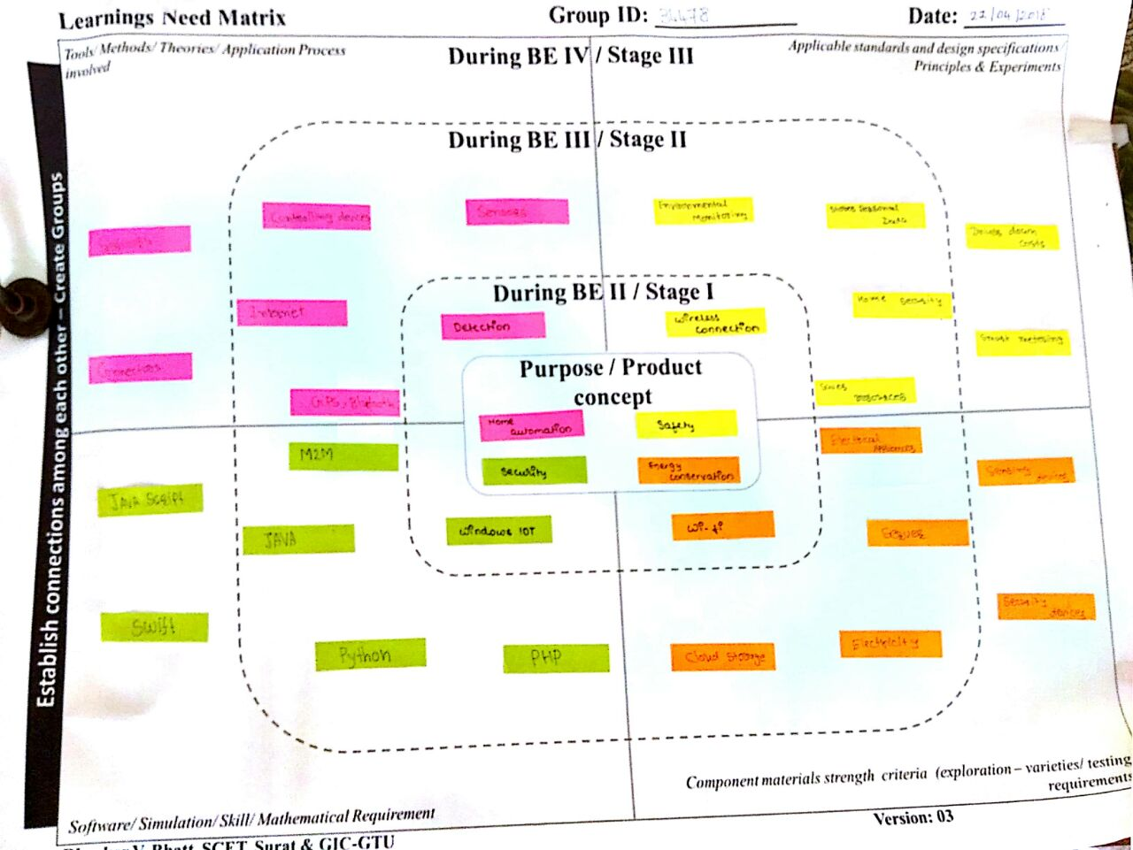

Figure 6 Learnings Need Matrix Canvas

We students, with the guidance of our Faculty Guide, need to identify at this stage, the needs for the generic learning, required while we develop their idea. The learning requirements will depend upon and may be specific for the concept/idea for our solution. This will help us to do the research in a timely manner so that we are able to obtain the specific learning/ understanding, we would require for designing the product. With understanding of the basic branch/ project related subjects, (after having discussions with and the guidance of our Faculty Guide) we will be able to identify tools/ use of software/ applicable standards/ material / design specifications/ theories/ principles/ methods/ experiments related needs to be acquired by us to complete our project successfully. After identifying the specific learning that will be required to develop our idea/product/concept further, we have to distribute learning requirements among the members of the group and each member has to learn minimum one component of LNM, in consultation with the Faculty Guide. We need to make LNM and include it in our report. LNM would include four major aspects as below:

1. Theories/ Methods/ Application Process Involved/ Mathematical Requirement
2. Applicable Standards and Design Specifications/ Principles & Experiments
3. Software/ Tools/ Simulation Methods/ Skill
4. Components Materials’ & strengths criteria (Exploration- varieties/testing requirements)

# Rough Prototype Model

# C:\Users\User\Desktop\IT Study Material\SY 1 4S\Design\IoT\WhatsApp Image 2018-04-23 at 12.45.15 PM.jpeg

Figure 7 Prototype

# Conclusion

In conclusion, using the Internet of Things, computing power can be generated with very low-powered devices, home automation will gradually become a technology that will easy for us to build and develop for on a daily basis.